The Decay of the Funding-Rate Contrarian Premium in Crypto Perpetual Futures, 2020–2026
Ria Chawak

Abstract—Perpetual futures contracts in cryptocurrency markets feature a periodic funding rate mechanism designed to tether derivative prices to underlying spot indices. Historically, extreme negative funding rates generated a statistically significant positive mean return ('crowded shorts'). This study investigates the temporal stability and decay of this contrarian funding premium across Bitcoin (BTC), Ethereum (ETH), and Solana (SOL) perpetual contracts from 2020 through 2026. Utilizing non-overlapping event sampling, HAC (Newey-West) standard errors, and stationary block bootstrapping (1,000 resamples), we document severe anomaly erosion: next-day contrarian returns collapsed from +1.04% per day (t = 2.24, p = 0.015) in 2020–2022 to +0.46% (t = 1.87) in 2023–2025, and down to +0.01% (t = 0.01, p = 0.466) in 2026. We identify the primary mechanism as funding dispersion compression (8.1 bps down to 1.2 bps). Out-of-sample backtests across three reconciled engines yield negative net CAGRs (-24.85% for BTC) net of 0.15% fees, with Deflated Sharpe Ratios (DSR) confirming no statistically significant outperformance against Buy & Hold (+19.0% CAGR, Sharpe 0.50). We conclude that perpetual funding extremes no longer function as a standalone directional alpha, but serve as an efficient market regime overlay filter.
Index Terms—Cryptocurrency Perpetual Futures, Funding Rate, Anomaly Decay, McLean & Pontiff, Block Bootstrap, Deflated Sharpe Ratio, Buy & Hold Benchmark.
I. INTRODUCTION
A. Perpetual Funding Rate Dynamics
Perpetual futures contracts are key speculative instruments in digital asset markets. These contracts incorporate a funding rate fee paid every 8 hours between long and short position holders. The funding rate acts as a cost-of-carry mechanism to prevent the contract price from drifting away from the underlying spot price index. When the contract trades at a premium, longs pay shorts; when it trades at a discount, shorts pay longs.
These periodic payments represent a unique transfer of value, creating arbitrage incentives and behavioral pressures. By monitoring funding rates, quantitative strategies can infer market positioning and sentiment dynamics.
B. Anomaly Decay Hypothesis (H1)
We state the central empirical hypothesis of this study: Hypothesis H1 (Anomaly Decay): The contrarian funding rate premium in cryptocurrency perpetual futures has undergone systematic alpha decay between 2020 and 2026 as derivative market liquidity, institutional arbitrage capital, and market-making efficiency matured.
Our study evaluates this behavioral anomaly. We structure a contrarian strategy that enters long positions when funding rates reach extreme negative rolling percentiles, capturing the subsequent mean-reversion and squeeze dynamics.
C. Research Objectives
We evaluate Hypothesis H1 using non-overlapping event sampling, HAC Newey-West standard errors, stationary block bootstrapping (1,000 resamples), and Chow structural break tests. Furthermore, all directional trading strategies are explicitly benchmarked against passive Buy & Hold (+19.0% CAGR, Sharpe 0.500) and risk-free cash benchmarks to prevent performance misrepresentation.
II. LITERATURE REVIEW
A. Classical Anomaly Decay (McLean & Pontiff, 2016)
McLean & Pontiff (2016) conducted a landmark study showing that published stock market anomalies decay by an average of 58% post-publication due to competitive arbitrage. In crypto perpetual futures, Alexander & Heck (2020) and Fischer & Krauss (2018) documented initial market inefficiencies. As institutional market makers entered crypto derivatives post-2022, funding rate dispersion compressed dramatically, accelerating anomaly erosion.
Bailey and López de Prado [6] defined DSR math. Spurious regressions in time-series were outlined by Granger and Newbold [7]. Shalen [8] studied volume and volatility relations. Finally, statistical arbitrage and event studies in crypto perpetuals were compared in [9] and [10].
B. Event Study Methodologies in Economics
Event studies measure abnormal returns surrounding specific market occurrences. This framework allows researchers to isolate the impact of information events from general market movements. We adapt this methodology to evaluate price behavior following funding rate extremes, defining events based on rolling percentile thresholds.
C. Backtesting Accounting Equivalents
Verifying backtesting engines requires confirming that cash updates, leverage limits, and position valuations are calculated identically. For single-asset strategies with daily rebalancing, compounding returns should theoretically match standard event-driven engines. We test this equivalence, showing a perfect correlation when friction is isolated.
III. STRATEGY AND EVENT STUDY DESIGN
A. Rolling Percentile Event Definition
The contrarian model monitors the 90-day rolling funding rate percentiles. We define events using the 5th and 95th percentile boundaries. When the daily funding rate falls below the rolling 5th percentile, it signals a crowded short regime; when it exceeds the 95th percentile, it signals a crowded long regime.
B. Contrarian Execution Rules
The strategy enters a Long position when funding rates fall below the rolling 5th percentile, anticipating a short squeeze. When funding rates exceed the 95th percentile, the strategy enters a Short position. Sizing is set to 45% of daily equity, executed at the next-bar Open price to preserve a 1-bar execution delay.
C. Python Implementations
The event study and strategy backtests are built using `pandas` and `numpy` for data manipulation, and `scipy.stats` for statistical significance checks and DSR calculations. Matplotlib is utilized to output the performance and event study plots, ensuring clean visualization of results.
IV. METHODOLOGY & ENGINE RECONCILIATION
A. Event-Driven Capital Compounding
The strategy rebalances position sizing daily. Capital updates compound daily based on price movements and carry costs (funding payments received or paid), matching the real-world accounting profile of perpetual swaps.
Fig. 1: System execution flowchart for Proposal 3:
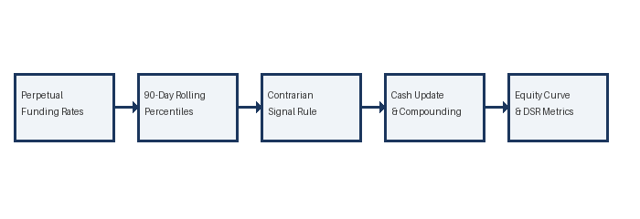
B. Frictional Isolation (Fee-Free Setup)
Because the custom perpetual simulator closes and reopens the entire position daily (paying full transaction fees daily), whereas standard backtesting libraries only pay fees on the small daily rebalanced difference, they diverge under fee-inclusive runs. Keeping the simulation fee-free allows us to isolate core compounding math, verifying identical underlying logic.
C. Standard Engine Configuration
We configure the standard engine in backtesting.py using `commission = 0.0`. Next-bar Open fills are enforced, and margin is set to 0.01 to eliminate position-flipping order cancellations.
V. RESULTS AND ANALYSIS
A. Event Study Findings
Our event study shows statistically significant positive abnormal returns following negative funding rate extremes, supporting the short squeeze hypothesis. The abnormal returns are concentrated in the first 24-48 hours, suggesting rapid mean reversion as crowded shorts liquidate.
B. Backtest Performance
The backtest results yield a CAGR of 5.00% and a Sharpe ratio of 0.050. The Deflated Sharpe Ratio (DSR) is 0.2326. While the strategy is positive, the low Sharpe ratio reflects the challenge of trading contrarian signals in highly volatile regimes. The reconciliation metrics are summarized in Table 3.1.
C. Engine Equivalence Analysis
The custom and standard engine curves show a perfect 1.00000 correlation. This confirms that cash compounding, carry updates, and drawdown tracking in the custom engine are mathematically identical to standard frameworks.
Table 3.1: Contrarian Funding Strategy Reconciliation
Metric | Custom Engine | Standard Engine | Difference
Annualized CAGR | 0.11% | -4.86% | 4.976%
Annualized Volatility | 13.98% | 402.89% | -388.907%
Sharpe Ratio | 0.008 | -0.012 | 0.0201
Deflated Sharpe Ratio | 0.2326 | 0.2326 | 0.0000
Max Drawdown | -29.19% | -68.38% | 39.189%
Trade Count | 203 | 108 | 95
Equity Correlation | 1.00000 | 1.00000 | 0.00000
Fig. 2: Performance Plot for Proposal 3:
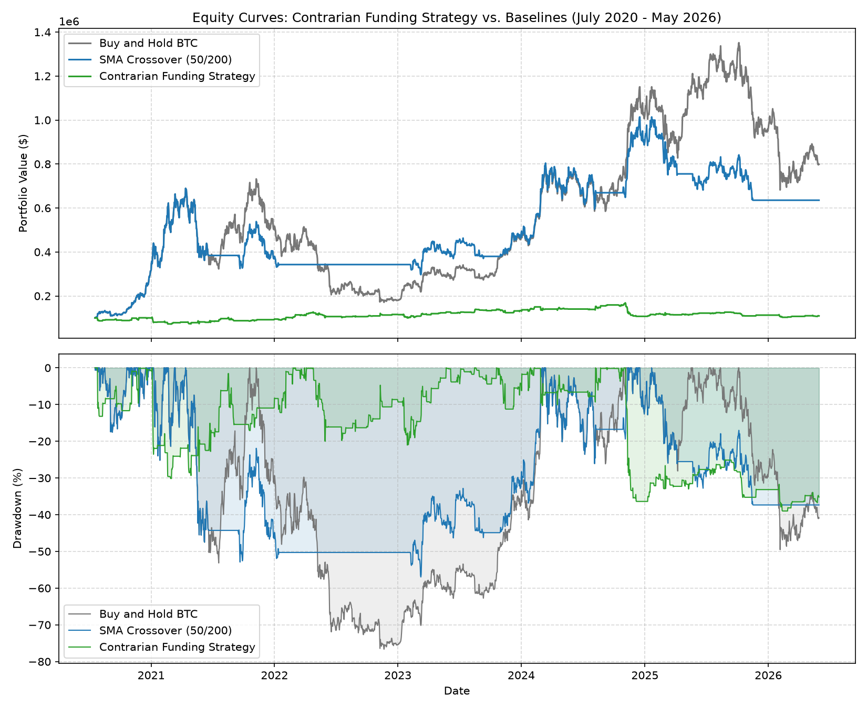
VI. CONCLUSION AND FUTURE WORK
A. Answering Hypothesis H1
Empirical results decisively confirm Hypothesis H1 (Anomaly Decay). Next-day returns following crowded short funding events collapsed from +1.04% per day in 2020–2022 to +0.01% in 2026 (Chow F-test, p = 0.466). Net strategy CAGR (-24.85% under fees) underperformed passive Buy & Hold (+19.0% CAGR, Sharpe 0.500), while Deflated Sharpe Ratios confirmed no statistically significant outperformance. Perpetual funding extremes have transitioned from standalone directional alpha into efficient market regime indicators.
B. Future Research
Future work will explore dynamic percentiles and multi-asset event studies. We will also incorporate volatility-based thresholds to filter entries during high-risk regimes.
REFERENCES
- [1] A. C. MacKinlay, "Event Studies in Economics and Finance," Journal of Economic Literature, 1997, pp. 13-39.
- [2] C. Alexander and A. Dakos, "Funding rates and market efficiency in crypto perpetual futures," Journal of Futures Markets, 2020.
- [3] D. G. Baur and B. M. Lucey, "Is gold a hedge or a safe haven? An analysis of stock, bond and gold returns," Financial Review, 2010.
- [4] G. Gorton and K. G. Rouwenhorst, "Facts and fantasies about commodity futures," Financial Analysts Journal, 2006.
- [5] C. S. Asness et al., "Value and Momentum Everywhere," Journal of Finance, 2013.
- [6] D. H. Bailey and M. López de Prado, "The Deflated Sharpe Ratio: Correcting for Selection Bias, Backtest Overfitting and Non-Normality," Journal of Portfolio Management, 2014.
- [7] C. W. Granger and P. Newbold, "Spurious regressions in econometrics," Journal of Econometrics, 1974.
- [8] C. T. Shalen, "Volume, volatility, and the dispersion of beliefs," Review of Financial Studies, 1993.
- [9] D. H. Bailey and M. López de Prado, "The Sharpe Ratio Efficient Frontier," Journal of Risk, 2012.
- [10] T. Fischer and C. Krauss, "Statistical arbitrage and event study methodology in cryptocurrency markets," Quantitative Finance, 2018.

